**Project Development Phase**

**Model Performance Test**

|  |  |
| --- | --- |
| Date | 17 May 2023 |
| Team ID | NM2023TMID18602 |
| Project Name | ESTIMATION AND PREDICTION OF HOSPITALIZATION AND MEDICAL CARE COSTS |

**Model Performance Testing:**

Project team shall fill the following information in model performance testing template.

|  |  |  |
| --- | --- | --- |
| **S.No.** | **Parameter** | **Screenshot / Values** |
|  | Dashboard design | No of Visulizations / Graphs - 12 |
|  | Data Responsiveness | HOAPITAL MEDICAL CARE INSURANCE DATA |
| 3. | Amount Data to Rendered (DB2 Metrics) | DB2 |
| 4. | Utilization of Data Filters | UTILIZATION DATA FILTERS ARE TWO |
| 5. | Effective User Story | No of Scene Added - 3 |
| 6. | Descriptive Reports | No of Visulizations / Graphs - 5 |

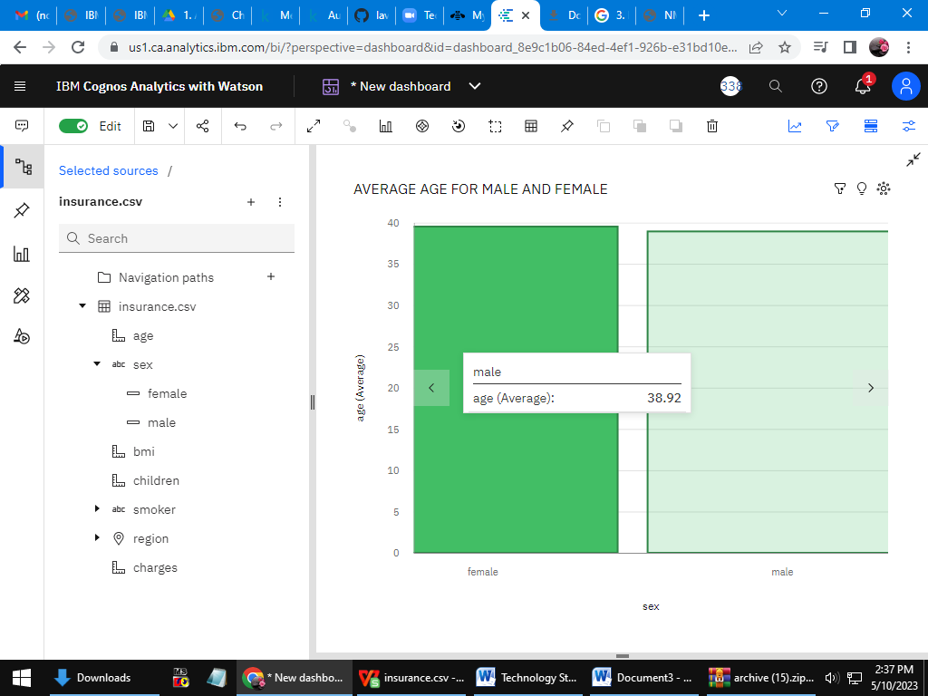

LINK:action=view&mode=dashboard&subView=model000001880514b0c6\_00000000https://us1.ca.analytics.ibm.com/bi/?perspective=dashboard&pathRef=.my\_folders%2Fdatavisuliation&

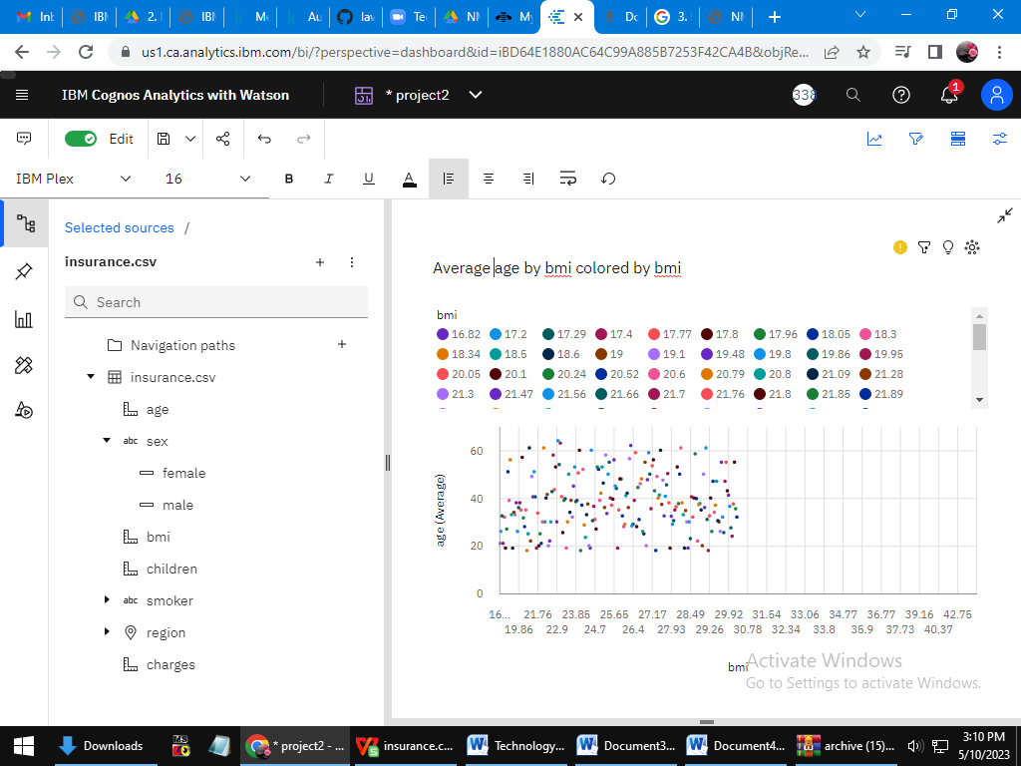

Link:<https://us1.ca.analytics.ibm.com/bi/?perspective=dashboard&pathRef=.my_folders%2Fdatavisuliation&action=view&mode=dashboard&subView=model000001880514b0c6_00000000>

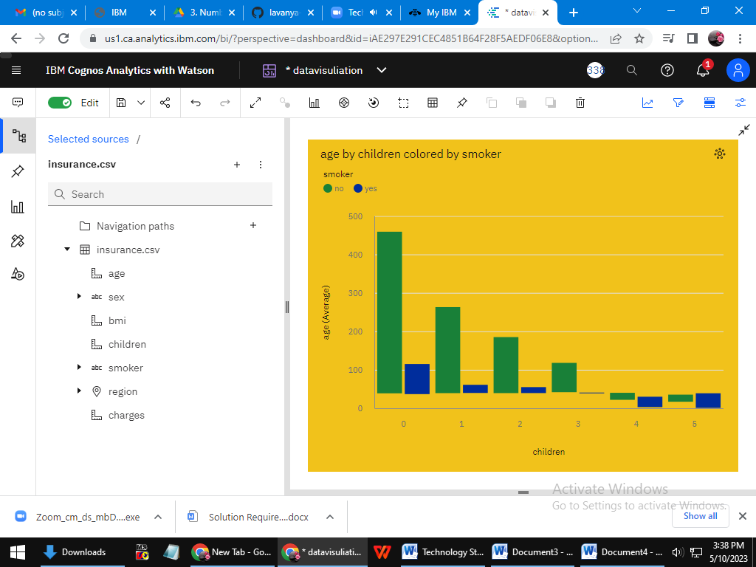

LINK:<https://us1.ca.analytics.ibm.com/bi/?perspective=dashboard&pathRef=.my_folders%2Fdatavisuliation&action=view&mode=dashboard&subView=model000001880514b0c6_00000000>

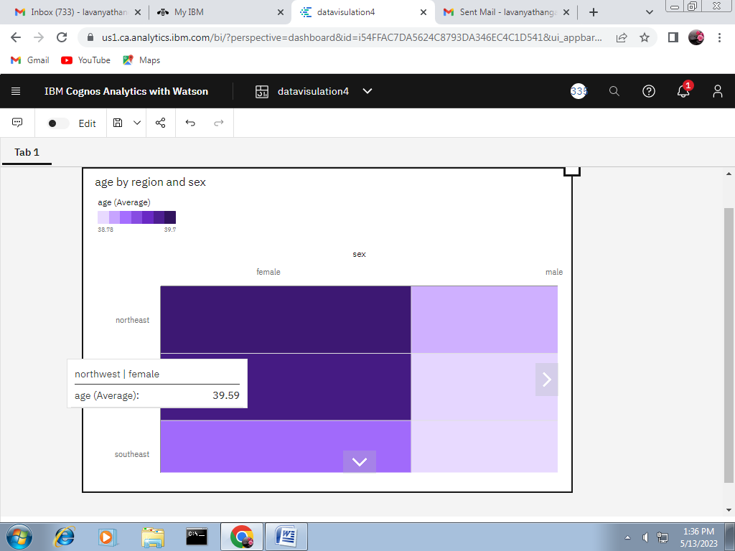

Link: <https://us1.ca.analytics.ibm.com/bi/?perspective=dashboard&pathRef=.my_folders%2Fdatavisulation4&action=view&mode=dashboard&subView=model00000188141febb6_00000000>

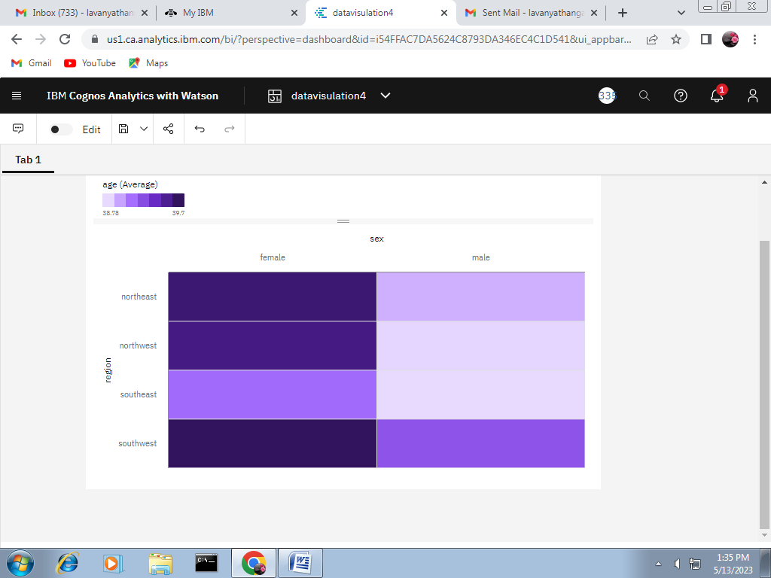

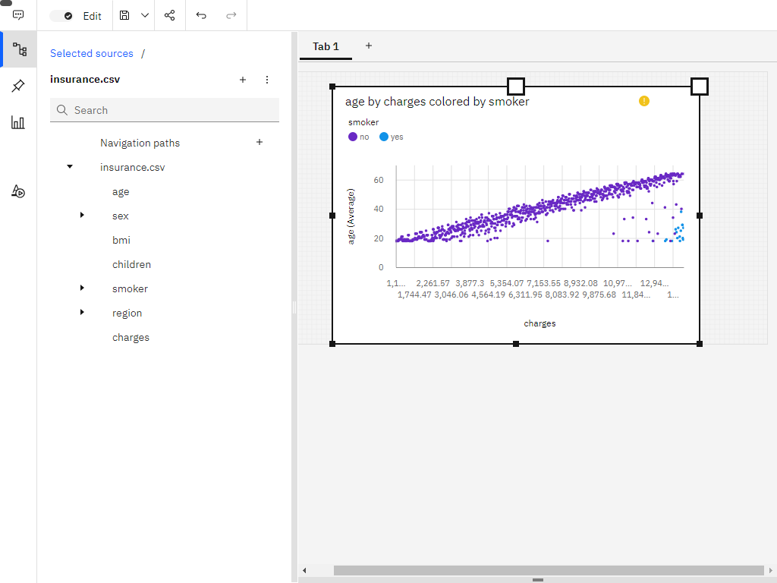

Link: <https://us1.ca.analytics.ibm.com/bi/?perspective=dashboard&pathRef=.my_folders%2Fdatavisulation5&action=view&mode=dashboard&subView=model000001881428d727_00000002>

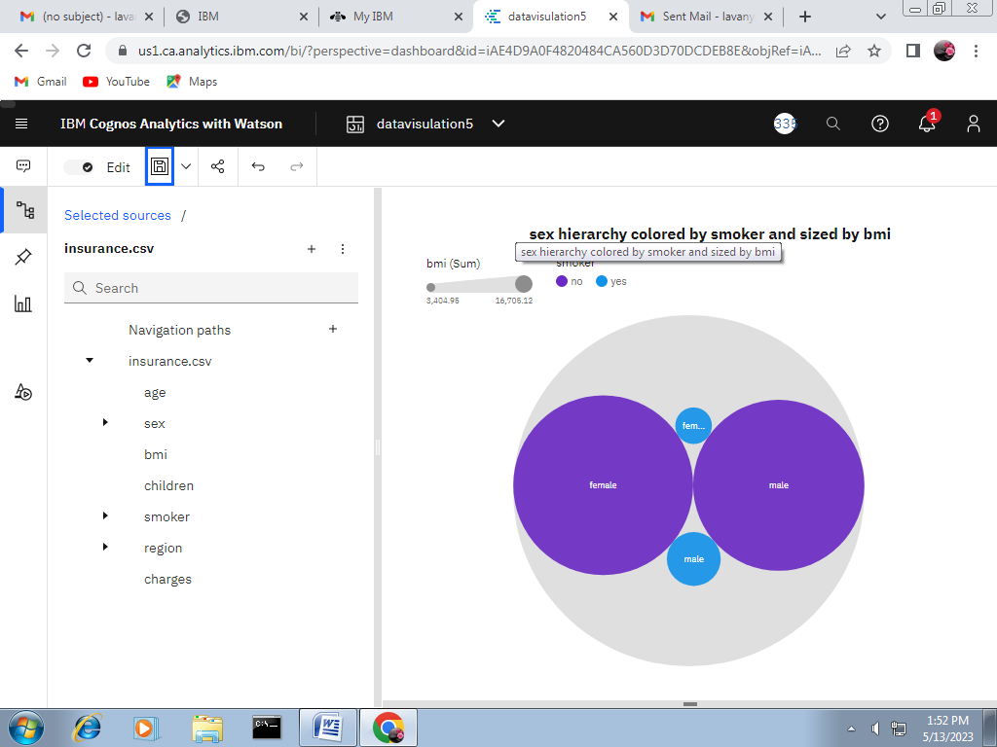

Link: <https://us1.ca.analytics.ibm.com/bi/?perspective=dashboard&pathRef=.my_folders%2Fdatavisulation5&action=view&mode=dashboard&subView=model000001881428d727_00000002>

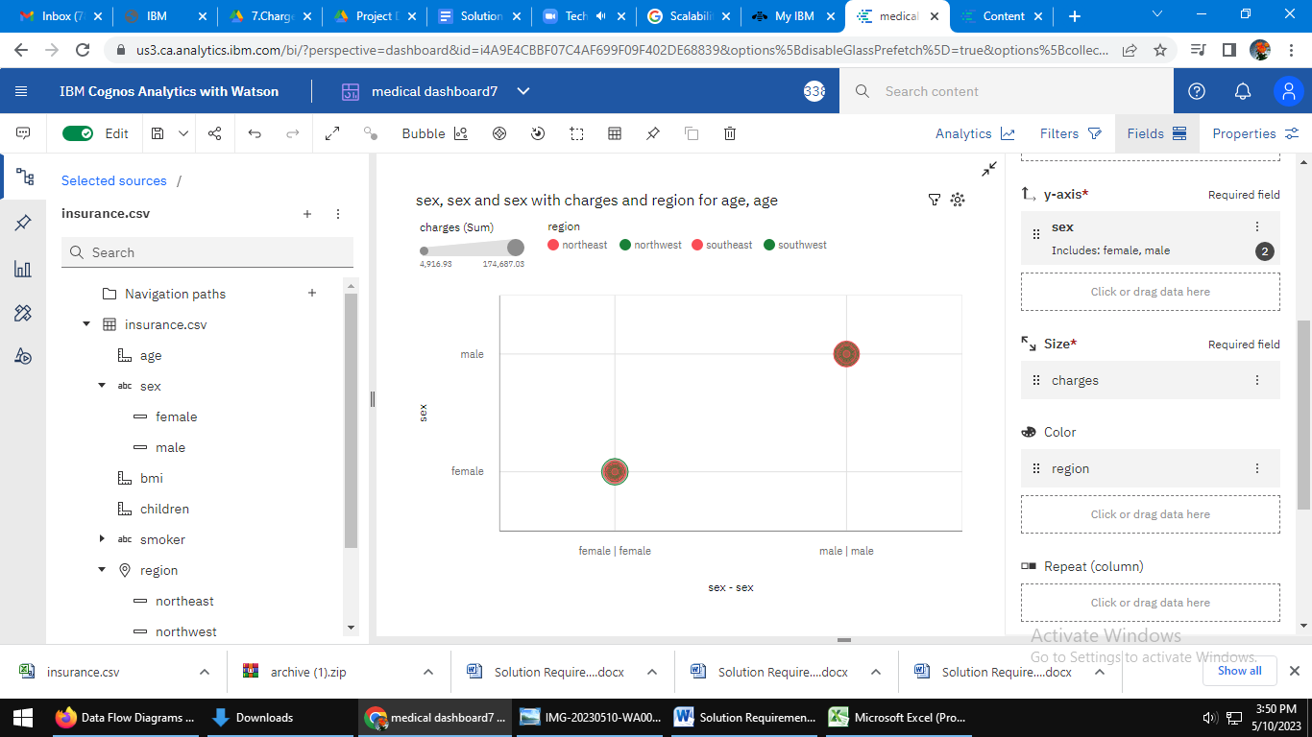

link:<https://us3.ca.analytics.ibm.com/bi/?perspective=dashboard&pathRef=.my_folders%2Fmedical%2Bdashboard7&action=view&mode=dashboard&subView=model000001880514c28f_00000000>

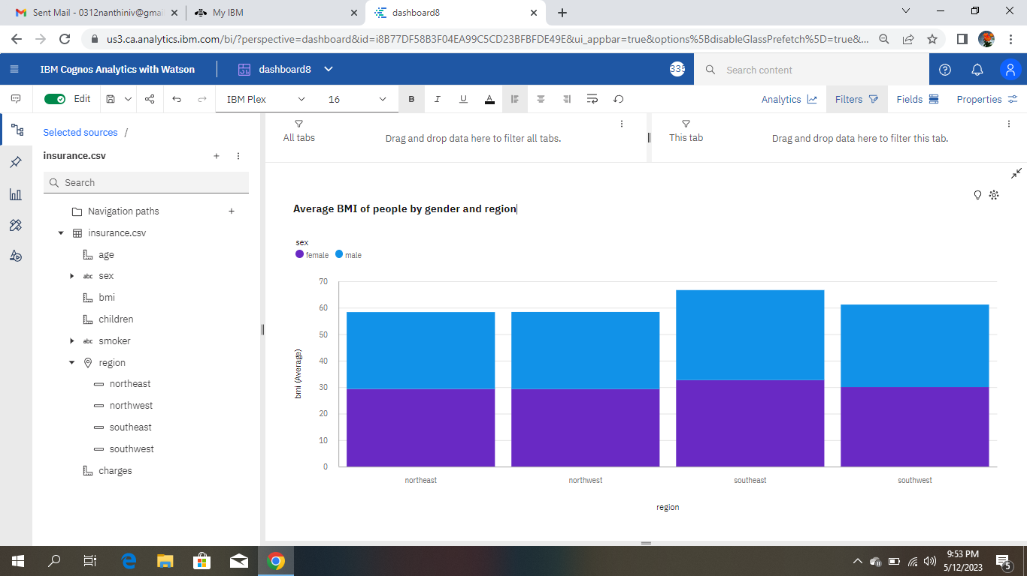

Link:[https://us3.ca.analytics.ibm.com/bi/?perspective=dashboard&pathRef=.my\_folders%2Fdashboard8&action=view&mode=dashboard&subView=model0000018814708b61\_00000000](https://us3.ca.analytics.ibm.com/bi/?perspective=dashboard&pathRef=.my_folders%2Fdashboard8&action=view&mode=dashboard&subView=model0000018814708b61_00000000" \t "_blank)

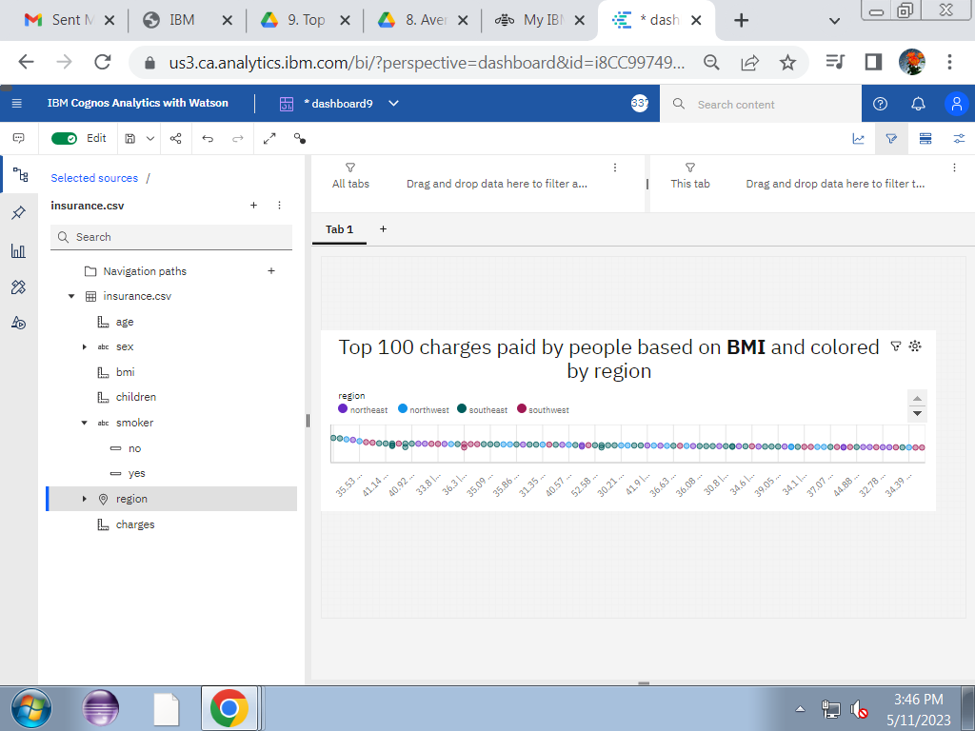

Link:[https://us3.ca.analytics.ibm.com/bi/?perspective=dashboard&pathRef=.my\_folders%2Fdashboard9&action=view&mode=dashboard&subView=model000001880a40253a\_00000002](https://us3.ca.analytics.ibm.com/bi/?perspective=dashboard&pathRef=.my_folders%2Fdashboard9&action=view&mode=dashboard&subView=model000001880a40253a_00000002" \t "_blank)

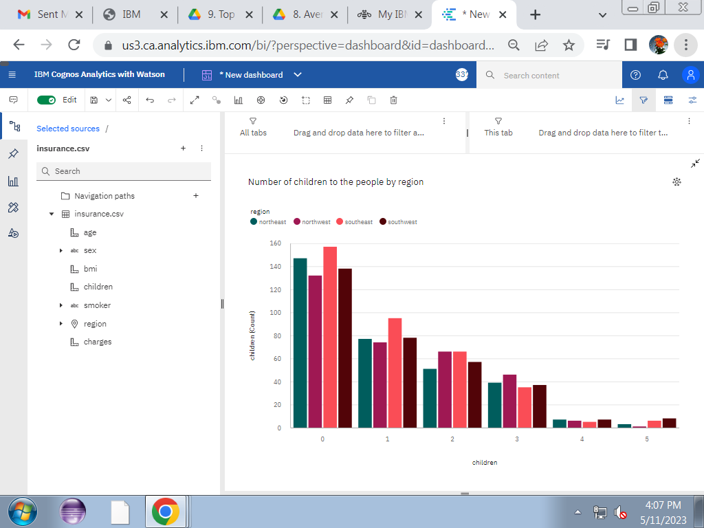

Link:[https://us3.ca.analytics.ibm.com/bi/?perspective=dashboard&pathRef=.my\_folders%2FNdashboard10&action=view&mode=dashboard&subView=model000001880a5503d7\_00000000](https://us3.ca.analytics.ibm.com/bi/?perspective=dashboard&pathRef=.my_folders%2FNdashboard10&action=view&mode=dashboard&subView=model000001880a5503d7_00000000" \t "_blank)

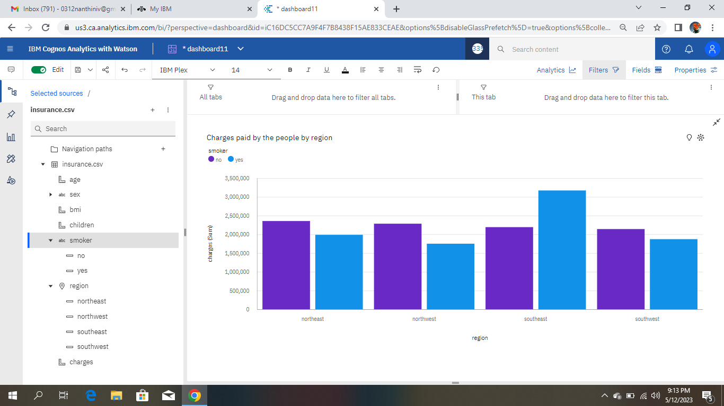

Link:[https://us3.ca.analytics.ibm.com/bi/?perspective=dashboard&pathRef=.my\_folders%2Fdashboard11&action=view&mode=dashboard&subView=model000001881452b641\_00000000](https://us3.ca.analytics.ibm.com/bi/?perspective=dashboard&pathRef=.my_folders%2Fdashboard11&action=view&mode=dashboard&subView=model000001881452b641_00000000" \t "_blank)

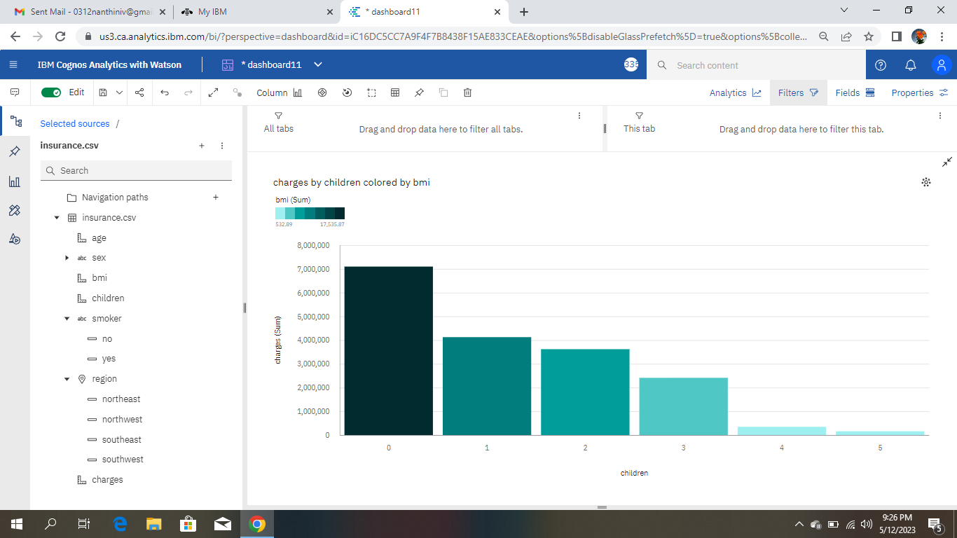

Link:<https://us3.ca.analytics.ibm.com/bi/?perspective=dashboard&pathRef=.my_folders%2Fdashboard11&action=view&mode=dashboard&subView=model0000018814655cf9_00000000>